Geneva Republican

Rev. Frederick Reklau's statement on participating in the Clergy Letter Project
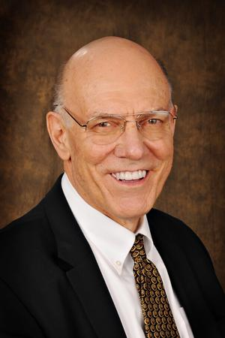

The Rev. Frederick Reklau of Winfield is a retired minister of the Evangelical Lutheran Church in America. The former pastor of St. Andrew's Lutheran Church in West Chicago, he now is an active member of St. Paul Lutheran Church in Wheaton.

By Anonymous
Suburban Life Publications
Posted Feb 11, 2011 @ 03:22 PM

Western suburbs —
The Clergy Letter Project is absolutely necessary, and I signed it gladly some time ago. Creationism and so-called "intelligent design" cannot stand unchallenged. Yet from another perspective, it should be unnecessary. How so? Because the "Bible vs. science" debate begins with the wrong question, and a wrong question can never lead to a right answer. It is simply wrongheaded to ask, "What does the Bible teach about science?" The mere facts of existence are not the point of scriptural revelation; the truth of God's love for the Creation — and for God's people in every age — is the point. Add to that the fact that our Western, scientific, post-Enlightenment views of what constitutes fact and truth are not, and cannot be, the views of ancient people in the Fertile Crescent. So what they would mean by "science" — though, there is no evidence they even knew the concept — would have to be vastly different from ours in 21st century America. The right question about Genesis 1-2 — which, by the way, are not the only reflections on origins in the Bible — is, "What is the purpose of these stories?" Seen in the framework of Scripture as a whole, which presents God's loving engagement with God's people, it is clear that those stories tell of our privileges and responsibilities as beings who have been created out of love by the One who has created all things, visible and invisible. Those who go mining for other meanings (of their own invention, not God's intention) rob the texts of their true purpose, and of their true power to shape and validate our lives as God's spirit-mind-body creations, made for a loving relationship with God and with others.
Copyright 2011 Geneva Republican. Some rights reserved

